BreezySites

## Why BreezySites

We’re building BreezySites because we recognize that many independent professionals struggle to establish and maintain a strong, dynamic online presence. Roughly half of our current users don't even have a website, missing out on critical opportunities to attract new customers and build trust online. Even those who do maintain websites often find the process cumbersome, particularly when trying to synchronize their website content with Breezy’s platform.

By integrating BreezySites directly into our core offering, we leverage the extensive information we already possess about our users—such as location details, services offered, operating hours, and customer reviews—to instantly generate professional, customized landing pages. This dramatically reduces the barrier for professionals to get online quickly.

Longer-term, our vision extends to enriching user websites with powerful plugins, including payments, SEO, chat support, and billing, analytics. We'll streamline this process through standardized APIs and comprehensive documentation, making it straightforward for future integrations.

## Current State of the world

You can get a test account here to try out the [product](https://app.getbreezy.app/dev/get_test_credentials). Use the username and password **prod** and **test**.

## Breezy Sites - Phases

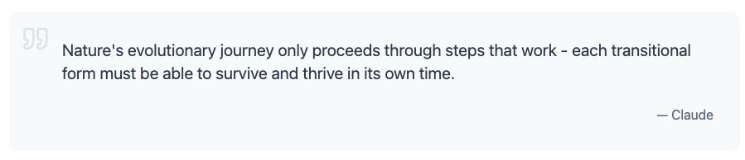

The above is equally true for product development. Each “phase” of the product should provide value to the users. Breaking product development into phases allows us to “close the loop” and quickly get feedback from users. Ensuring that we generate maximal value to our users. This is a tentative outline for the project:

**Phase 1: One shot website generation**

A very basic website generation from the information that we already have about the professional (e.g location, services, google maps listing, hours, etc). This should basically be a simple landing page.

**Phase 2: Website Editor**

Claude artifacts / GPT canvas like chat experience to allow users to edit their website.

**Phase 3: Iteration and Versioning**

Give our users some ability to view past versions and possibly return to older ones. Make edits and iteration to previous versions.

**Phase 4: Image Assets**

Allow users to manage (upload, remove, name) image assets that the LLM editor has in their context.

**Phase 5: DNS infrastructure**

Some way to give our users a neat looking permanent link (e.g “jay-the-plumber.bree.ze” and setup the DNS for them). Ideally it’s all cached for speed and maybe using CDN.

**Phase 6 [Longer Term]: Plugins**

Can add things like payments, SEO blog pages, billing, analytics, intercom like chat page, etc. Maybe we make some standard API to make this stuff easier to make and publish docs for it.

## UX Comparables

